Specimen Collection Cheat Sheet
*Do not pour out liquid from any transport tubes*
Collection Container | Acceptable Uses |  | Epic Order Codes
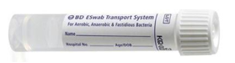  ESwab Transport System | Bacterial Culture | Superficial Wound | LAB4534
 |  | Deep Wound | LAB4533
 |  | Eye | LAB4511
 |  | Ear | LAB4510
 |  | Group B Strep Screen | LAB4531
 |  | Genital | LAB4515
 |  | Throat | LAB4528
 | Molecular / PCR | MRSA | LAB4610
 |  | MRSA and MSSA | LAB4611
 |  | Strep A PCR (reflex Group A Strep Screen) | LAB4539
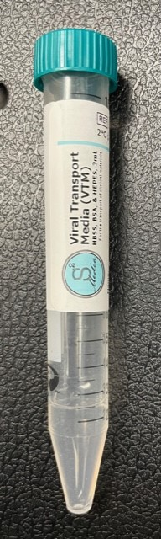  S2 Viral Transport Media (VTM) | Anterior Nasal (Large) Swab | Covid only | LAB4606
 |  | Covid/Flu/RSV | LAB4608
 | Nasopharyngeal (Small) Swab | Covid only | LAB4606
 |  | Covid/Flu/RSV | LAB4608
 |  | Respiratory Panel | LAB4612
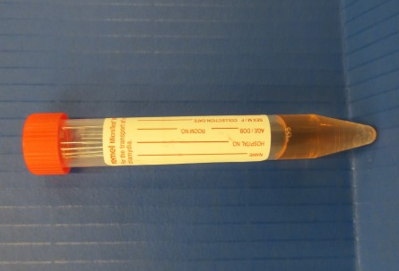  M4RT | Viral Lesions | HSV | Lab 5938 HSV
 |  | Varicella Zoster | Lab5392 VZVPV
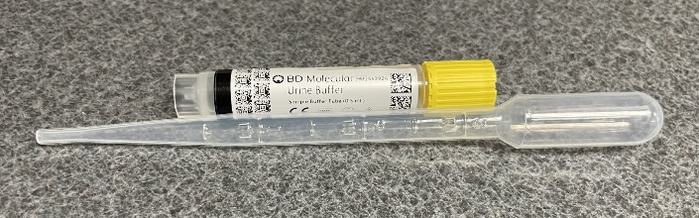  BD Molecular Urine Transport Kit | Chlamydia trachomatis, Neisseria gonorrhoeae, and Trichomonas PCR | CTGCTV PCR | LAB4603
 |  | CTGC PCR (No Trichomonas) | LAB4602
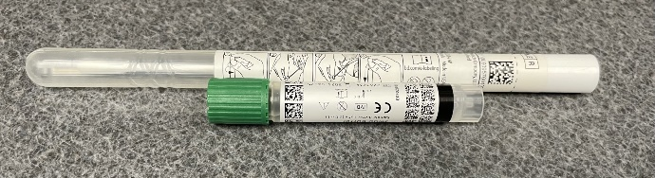  BD Molecular Swab Collection Kit | Chlamydia trachomatis, Neisseria gonorrhoeae, and Trichomonas PCR | CTGCTV PCR | LAB4603
 |  | CTGC PCR (No Trichomonas) | LAB4602
 | Vaginitis Panel | Bacterial Vaginosis  Trichomonas vaginalis  Candida species | LAB4567

