Stool Collection Containers
TEST NAME | COLLECTION CONTAINER | STABILITY | COLLECTION INSTRUCTIONS
Stool Culture  Cryptosporidium Antigen  Giardia Antigen | 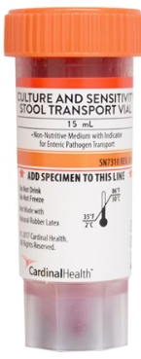  C&S Medium (Cary Blair Medium)  Yellow vial acceptable | Stool must be placed in the vial within one hour of collection.  Stool Culture -  Stable for 48 hours once inside the vial.  Crypto/Giardia – Stable for 2 weeks | IMPORTANT: Write patient’s full name, date of birth, date/time of collection, and collector’s name on all containers.  Deliver samples to the Laboratory as soon as possible after collection. For collections questions, call Microbiology (208-625-5828).  Patient should pass the stool into a clean, dry pan, or a special container mounted on the toilet for this purpose. Stool specimen cannot be mixed with urine.  Using the collection spoon inside the vial, add stool into the vial until the liquid reaches the red line.  DO NOT OVERFILL  Mix contents with the collection spoon. Tighten cap and shake firmly to ensure that the specimen is adequately mixed.  Store at room temperature.
Ova and Parasite (O&P) | 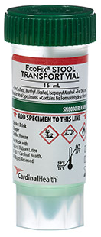  EcoFix | Stool must be placed in the vial within 30 minutes of collection.  Stable for 9 months
Clostridium difficile  (C. diff)  Fecal Lactoferrin/Fecal Leukocyte  Rotavirus  Fecal Elastase (Mayo) | Clean vial 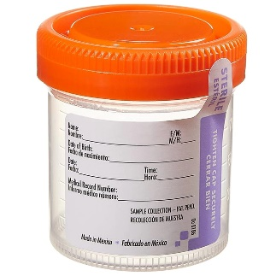(No preservatives)  Or sterile cup | C.diff – 2 days room temperature, 5 days refrigerated  Fecal Lactoferrin- 2 weeks room temperature or refrigerated  Rotavirus – 3 days refrigerated | Patient should pass the stool into a clean, dry pan, or a special container mounted on the toilet for this purpose. Stool specimen cannot be mixed with urine.  Using the collection spoon inside the vial, add stool into the vial until the liquid reaches the red line.  DO NOT OVERFILL  Note: Only liquid specimens are acceptable for C. diff testing (C. diff indications: Clinically significant diarrhea ≥ 3 loose stools in a 24 hour period, with moderate to high clinical suspicion of colitis.)  Store specimen in the refrigerator.
Fecal Occult Blood (IFOBT) – (Urinalysis) | 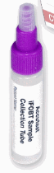 | Transport at room temperature | Randomly scrape surface of unpreserved stool sample with sampling probe until completely covering grooves. (Insert into fecal 3-6 times). Insert probe into sample bottle. Screw purple or snap green cap on tightly. Shake to mix.
H. pylori (Mayo) | 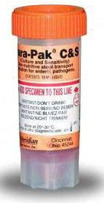  Culture and Sensitivity Stool Transport (orange top) | Place feces in preservative within 2 hours of collection. | Send at room temperature.

