Stool Collection Containers
TEST NAME | COLLECTION CONTAINER | STABILITY | COLLECTION INSTRUCTIONS
Stool Culture  GI Panel PCR  Cryptosporidium Antigen  Giardia Antigen  Yersinia culture (Mayo)  GI Pathogen Panel PCR (Mayo) | 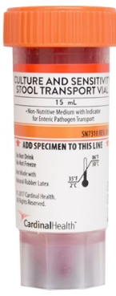  C&S Medium (Cary Blair Medium)  Yellow vial acceptable | Stool must be placed in the vial within one hour of collection.  Stool Culture- 2 days room temp, 4 days refrig  GI Panel PCR- 24 hrs room temp, 4 days refrig  Crypto/Giardia – 3 days room temp, 2 weeks refrig | IMPORTANT: Write patient’s full name, date of birth, date/time of collection, and collector’s name on all containers.  Deliver samples to the Laboratory as soon as possible after collection. For collections questions, call Microbiology (208-625-5828).  Patient should pass the stool into a clean, dry pan, or a special container mounted on the toilet for this purpose. Stool specimen cannot be mixed with urine.  Using the collection spoon inside the vial, add stool into the vial until the liquid reaches the red line.  DO NOT OVERFILL  Mix contents with the collection spoon. Tighten cap and shake firmly to ensure that the specimen is adequately mixed.  Store specimen in the refrigerator.
Ova and Parasite (O&P) Mayo | 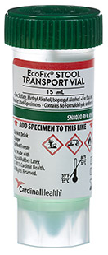  EcoFix | Stool must be placed in the vial within 30 minutes of collection.  Stable for 21 days room temp or refrig
Clostridium difficile  (C. diff)  Fecal Lactoferrin/Fecal Leukocyte  Rotavirus  Fecal Elastase (Mayo)  Calprotectin (Mayo)  IFOBT | Clean vial 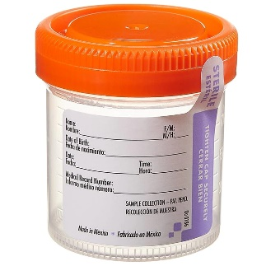  (No preservatives)  Or sterile cup | C.diff – 2 days room temp, 5 days refrig  Fecal Lactoferrin- 3 days room temp or refrig  Rotavirus – 3 days refrig  Elastase/Calprotectin- 72 hours refrig, 7 days frozen | Patient should pass the stool into a clean, dry pan, or a special container mounted on the toilet for this purpose. Stool specimen cannot be mixed with urine.  DO NOT OVERFILL  Note: Only liquid specimens are acceptable for C. diff testing (C. diff indications: Clinically significant diarrhea ≥ 3 loose stools in a 24 hour period, with moderate to high clinical suspicion of colitis.)  Store specimen in the refrigerator.
Fecal Occult Blood (IFOBT) | 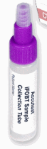 | Collection device stable for 30 days room temp or refrig  Fresh stool (no preserve) room temp or refrig 2 Days | Randomly scrape/poke surface of unpreserved stool sample with sampling probe until completely covering grooves. (Insert into fecal 3-6 times). Insert probe into sample bottle. Screw purple or snap green cap on tightly. Shake to mix.
H. pylori (Mayo) | 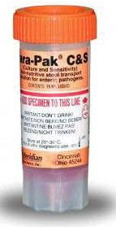  Culture and Sensitivity Stool Transport (orange top) | Place feces in preservative within 2 hours of collection.  Room temp 7 days, or refrig 7 days | Send to Mayo

